Performance Test Analysis – api.demoblaze.com
Test Setup:
- 50 concurrent users
- Ramp-up: 10 seconds
- Duration: 120 seconds
- Loop: controlled by duration
• Key Metrics (copy from Aggregate Report):
- Average Response Time: 458 ms
- 90th Percentile: 525 ms
- 95th Percentile: 3391 ms
- Throughput: 24.1/min
- Error Rate: 0%
• Bottlenecks observed (example):
- Login step had highest average response time (possible session creation overhead)
- Add to Cart showed occasional spikes (possible server-side validation delay)

SUMMARY REPORT
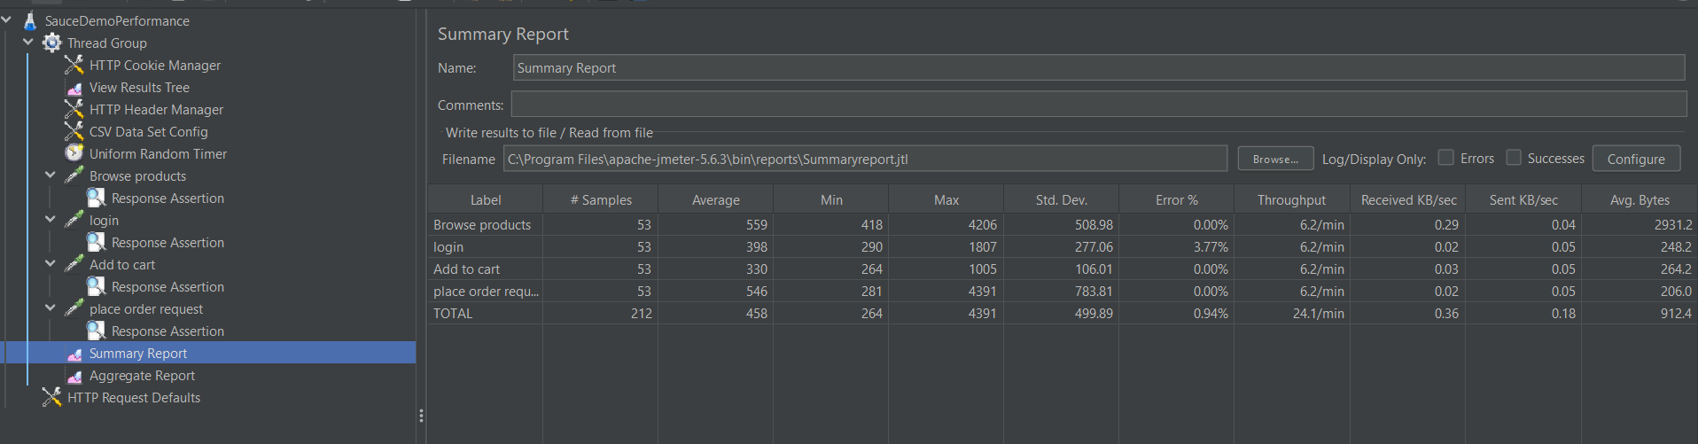

VIEW RESULTS TREE
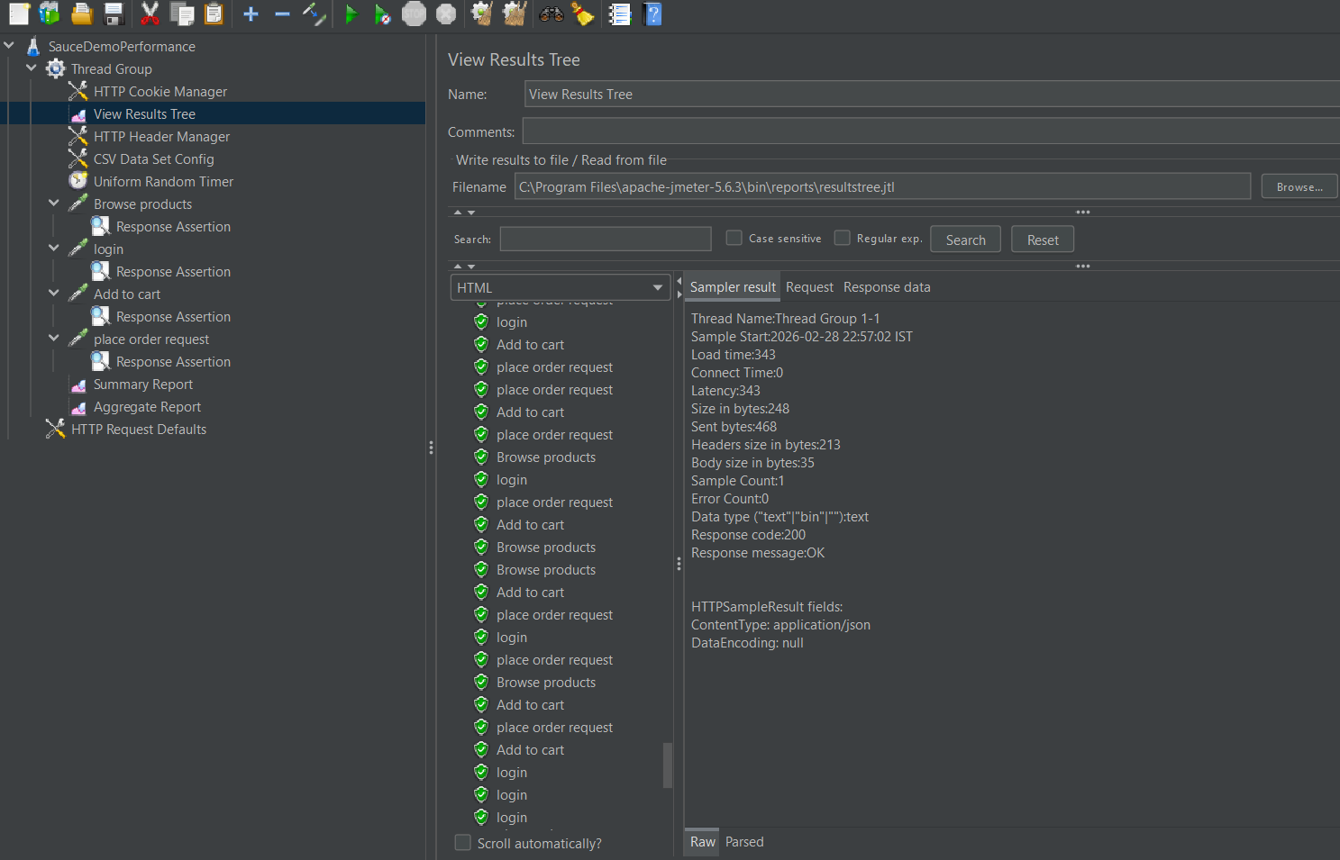

GRAPH RESULTS
